Art 100: Introduction to Art

OCL Project

Module 3

The Visual Language: Elements and Principles of Art

Just as spoken language is based on fundamental letters, sounds and grammar, visual art is based on elements and principles that, when used together, create works that communicate ideas and meaning to the viewer. We can refer to them as the building blocks of composition in visual art. A composition is the organized layout of an image or object according to the rules of design. The best way to understand the elements and principles is to study them within a variety of works of art.

The Element of the Point

A point is the visual element upon which all others are based. It can be defined as a singularity in space or, in geometric terms, the area where two coordinates meet. When an artist marks a simple point on a surface, (also referred to as the ground), they immediately create a figure-ground relationship. That is, they divide the work between its surface and anything added to it. Our eyes differentiate between the two, and their arrangement has everything to do with how we see a final composition. The point itself can be used as a way to create forms. For example, Pointillism is a style of painting made famous by the French artist Georges Seurat in the late nineteenth century. He and others in the Pointillist group created paintings by juxtaposing points – or dots- of color that optically mixed to form lines, shapes and forms within a composition. Look at a detail from Seurat’s ‘La Parade de Cirque’ to see how this works. His large canvas Sunday Afternoon on the Grande Jatte is a testament to the pointillist style and aesthetic. Its creation was a painstaking process but one that generated new ways of thinking about color and form.
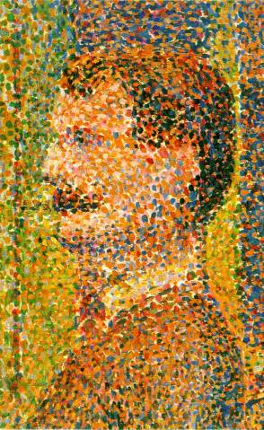
Georges Seurat, La Parade de Cirque, detail, 1887-89.
The Metropolitan Museum of Art, New York.
Licensed under Creative Commons

The Element of Line

Essentially, when you put two or more points together you create a line. A line can be lyrically defined as a point in motion. There are many different types of lines, all characterized by their length being greater than their width. Lines can be static or dynamic depending on how the artist chooses to use them. They help determine the motion, direction and energy in a work of art. We see line all around us in our daily lives; telephone wires, tree branches, jet contrails and winding roads are just a few examples. Look at the photograph below to see how line is part of natural and constructed environments.

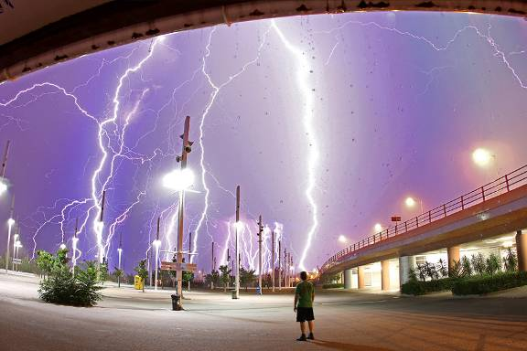
Photo by Chris Kotsiopoulos
Used by permission

In Chris Kotsiopoulos’s digital image of a lightning storm we can see many different lines. Certainly the jagged, meandering lines of the lightning itself dominate the image, followed by the straight lines of the light standards, the pillars holding up the overpass on the right and the guard rails attached to its side. There are more subtle lines too, like the gently arced line at the top of the image and the shadows cast by the poles and the standing figure in the middle. Lines are even implied by falling water droplets in the foreground.
The Nazca lines in the arid coastal plains of Peru date to nearly 500 BCE were scratched into the rocky soil, depicting animals on an incredible scale, so large that they are best viewed from the air. Let’s look at how the different kinds of line are made.

Diego Velazquez’s ‘Las Meninas’ from 1656, ostensibly a portrait of the Infanta Margarita, the daughter of King Philip IV and Queen Mariana of Spain, offers a sumptuous amount of artistic genius; its shear size (almost ten feet square), painterly style of naturalism, lighting effects and the enigmatic figures placed throughout the canvas –including the artist himself – is one of the great paintings in western art history. Let’s examine it (below) to uncover how Velazquez uses basic elements and principles of art to achieve such a masterpiece.

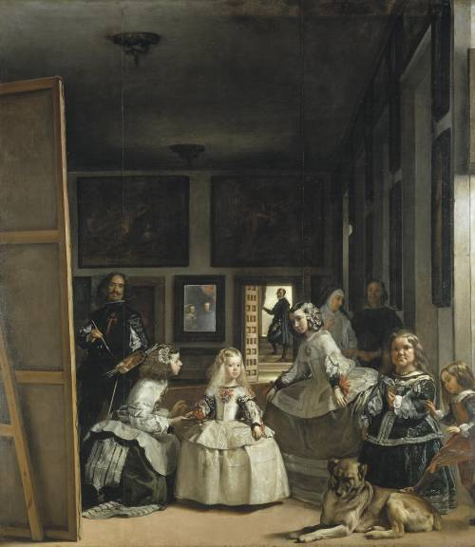
Diego Velazquez, Las Meninas, 1656, oil on canvas, 125.2” x 108.7”
Prado, Madrid. Licensed under Creative Commons

Actual lines are those that are physically present. The edge of the wooden stretcher bar at the left of ‘Las Meninas’ is an actual line, as are the picture frames in the background, and the linear decorative elements on the some of the figure’s dresses. How many other actual lines can you find in the painting?

Implied lines are those created by visually connecting two or more areas together. The space between the Infanta Margarita – the blonde central figure in the composition – and the ‘meninas’, or maids of honor, to the left and right of her, are implied lines. Both set up a diagonal relationship that implies movement. By visually connecting the space between the heads of all the figures in the painting we have a sense of jagged motion that keeps the lower part of the composition in motion, balanced against the darker, more static upper areas of the painting. Implied lines can also be created when two areas of different colors or tones come together. Can you identify more implied lines in the painting? Where? Implied lines are found in three-dimensional artworks too. The sculpture of the Laocoon below, a figure from Greek and Roman mythology, is, along with his sons, being strangled by sea snakes sent by the goddess Athena as wrath against his warnings to the Trojans not to accept the Trojan horse. The sculpture sets implied lines in motion as the figures writhe in agony against the snakes.

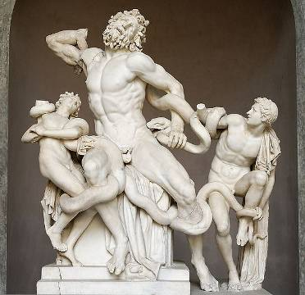
Laocoon Group, Roman copy of Greek original, Vatican Museum, Rome.
Photo by Marie-Lan Nguyen and licensed under Creative Commons

Straight or classic lines provide structure to a composition. They can be oriented to the horizontal, vertical or diagonal axis of a surface. Straight lines are by nature visually stable, while still giving direction to a composition. In the ‘Las Meninas’, you can see them in the canvas supports on the left, the wall supports and doorways on the right, and in the background in matrices on the wall spaces between the framed pictures. Moreover, the small horizontal lines created in the stair edges in the background help anchor the entire visual design of the painting.

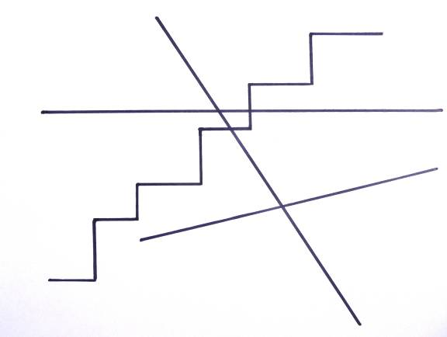
Straight or Classic Lines

Expressive lines are curved, adding an organic, more dynamic character to a work of art. Expressive lines are often rounded and follow undetermined paths. In ‘Las Meninas’ you can see them in the aprons on the girls’ dresses and in the dog’s folded hind leg and coat pattern. Look again at the Laocoon to see expressive lines in the figures’ flailing limbs and the sinuous form of the snakes. Indeed, the sculpture seems to be made up of nothing but expressive lines, shapes and forms.
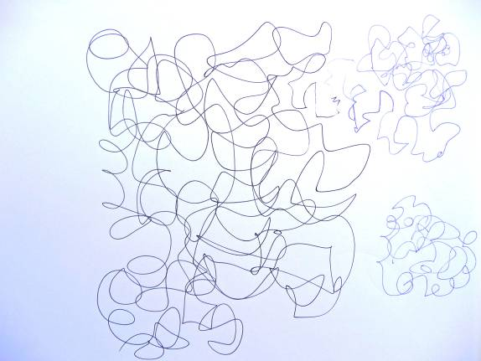
Expressive or Organic Lines

There are other kinds of line that encompass the characteristics of those above yet, taken together, help create additional artistic elements and richer, more varied compositions. Refer to the images and examples below to become familiar with these types of line.
Outline, or contour line is the simplest of these. They create a path around the edge of a shape. In fact, outlines define shapes.

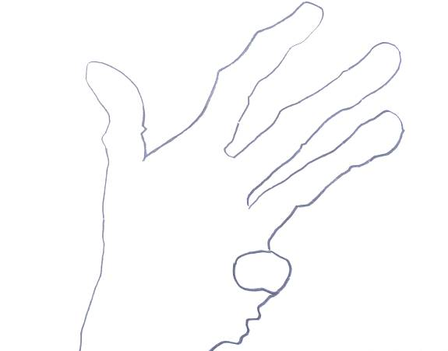
Outline or Contour Line

Cross contour lines follow paths across a shape to delineate differences in surface features. They give flat shapes a sense of form (the illusion of three dimensions), and can also be used to create shading.

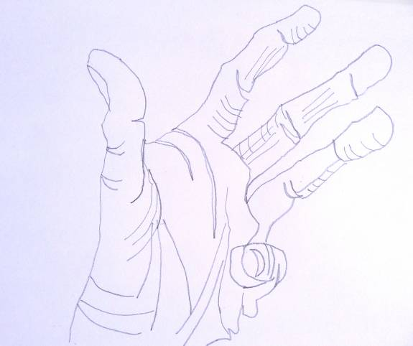
Cross Contour Lines

Hatch lines are repeated at short intervals in generally one direction. They give shading and visual texture to the surface of an object.

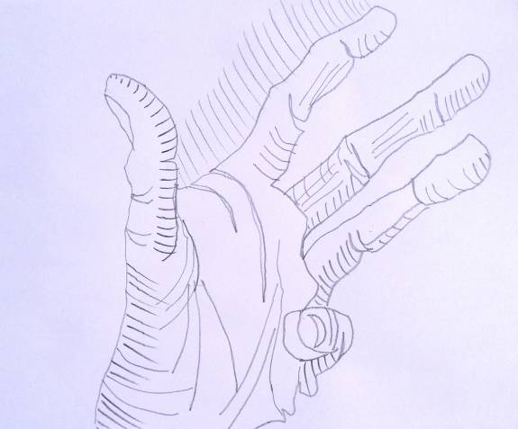
Hatch Lines

Cross-hatch lines provide additional tone and texture. They can be oriented in any direction. Multiple layers of cross-hatch lines can give rich and varied shading to objects by manipulating the pressure of the drawing tool to create a large range of values.

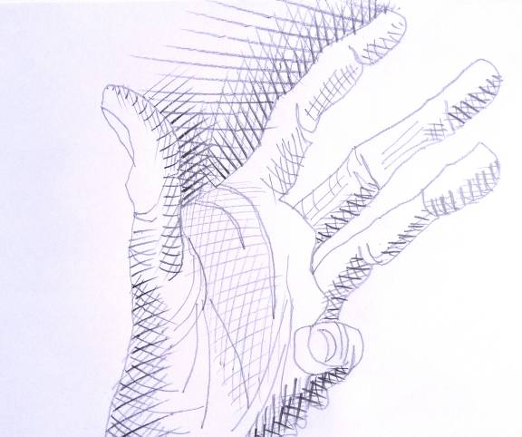

Cross-hatch Lines

Line quality is that sense of character embedded in the way a line presents itself. Certain lines have qualities that distinguish them from others. Hard-edged, jagged lines have a staccato visual movement while organic, flowing lines create a more comfortable feeling. Meandering lines can be either geometric or expressive, and you can see in the examples how their indeterminate paths animate a surface to different degrees.

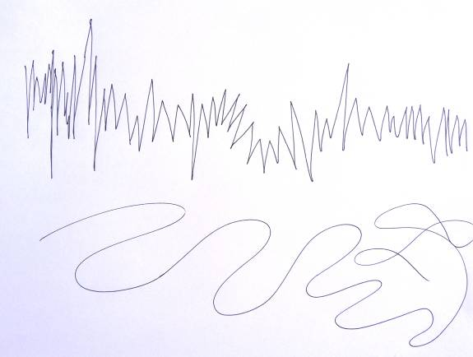
top: jagged line
bottom: meandering, organic line

Although line as a visual element generally plays a supporting role in visual art, there are wonderful examples in which line carries a strong cultural significance as the primary subject matter.

Calligraphic lines use quickness and gesture, more akin to paint strokes, to imbue an artwork with a fluid, lyrical character. To see this unique line quality, view the work of Chinese poet and artist Dong Qichang’s ‘Du Fu’s Poem’, dating from the Ming dynasty (1555-1637). A more geometric example from the Koran, created in the Arabic calligraphic style, dates from the 9th century.
Both these examples show how artists use line as both a form of writing and a visual art form. American artist Mark Tobey (1890-1976) was influenced by Oriental calligraphy, adapting its form to the act of pure painting within a modern abstract style described as white writing.

The Element of Shape

A shape is defined as an enclosed area in two dimensions. By definition shapes are always implied and flat in nature. They can be created in many ways, the simplest by enclosing an area with an outline. They can also be made by surrounding an area with other shapes or the placement of different textures next to each other – for instance, the shape of an island surrounded by water. Because they are more complex than lines, shapes do much of the heavy lifting in arranging compositions. The abstract examples below give us an idea of how shapes are made.

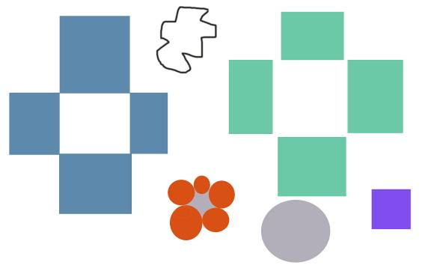
Ways of creating shapes.

Referring back to Velazquez’s ‘Las Meninas’, it is fundamentally an arrangement of shapes; organic and hard-edged, light, dark and mid-toned, that solidifies the composition within the larger shape of the canvas. Looking at it this way, we can view any work of art, whether two or three-dimensional, realistic, abstract or non-objective, in terms of shapes alone.

Positive/Negative Shapes
Shapes animate figure-ground relationships. We visually determine positive shapes (the figure) and negative shapes (the ground). One way to understand this is to open your hand and spread your fingers apart. Your hand is the positive shape, and the space around it becomes the negative shape. You can also see this in the example above. The shape formed by the black outline becomes positive because it’s enclosed. The area around it is negative. The same visual arrangement goes with the gray circle and the purple square. But identifying positive and negative shapes can get tricky in a more complex composition. For instance, the four blue rectangles on the left have edges that touch each other, thus creating a solid white shape in the center. The four green rectangles on the right don’t actually connect yet still give us an implied shape in the center. Which would you say is the positive shape? What about the red circles surrounding the gray star shape? Remember that a positive shape is one that is distinguished from the background. In ‘Las Meninas’ the figures become the positive shapes because they are lit dramatically and hold our attention against the dark background. What about the dark figure standing in the doorway? Here the dark shape becomes the positive one, surrounded by a white background. Our eyes always return to this figure as an anchor to the painting’s entire composition. In three dimensions, positive shapes are those that make up the actual work. The negative shapes are the empty spaces around, and sometimes permeating through the work itself. The Laocoon is a good example of this. A modern work that uses shapes to a dramatic effect is Alberto Giacometti’s ‘Reclining Woman Who Dreams’ from 1929. In an abstract style the artist weaves positive and negative shapes together, the result is a dreamy, floating sensation radiating from the sculpture.

Plane

A plane is defined as any surface area in space. In two-dimensional art, the picture plane is the flat surface an image is created upon; a piece of paper, stretched canvas, wood panel, etc. A shape’s orientation within the picture plane creates a visually implied plane, inferring direction and depth in relation to the viewer. The graphic below shows three examples.

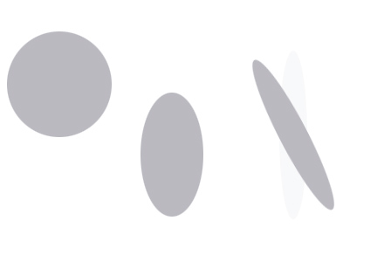
Implied planes on a 2-dimensional surface

Traditionally the picture plane has been likened to a window the viewer looks through to a scene beyond, the artist constructing a believable image showing implied depth and planar relationships. ‘Landscape with the Fall of Icarus’ , painted by Pieter Breughel the Elder in 1558 (below) presents us with the tragic ending to the Greek myth involving Icarus, son of Daedalus, who, trying to escape from the island of Crete with wings of wax, flies too close to the sun and falls to earth. Breughel shows us an idyllic landscape with farmers tilling their fields, each terraced row a different plane of earth, and shepherds tending their flocks of sheep in the foreground. He depicts the livestock in positions that infer they are moving in different directions in relation to the ‘window’ of the picture plane. We look further to see a gradual recession to the sea and a middle ground dominated by a ship under sail. The curves of the billowing sails imply two or three different planes. The background of the painting shows the illusion of deep space, the massive cliffs now small in relation to the foreground, and the distant ship near the center as smaller and lighter in tone. In the grandeur of the scene Icarus falls into the sea unnoticed just off shore to the lower right, only his legs still above water. The artist’s use of planar description is related to the idea of space and how it’s depicted in two dimensions. We will look at the element of space just ahead.
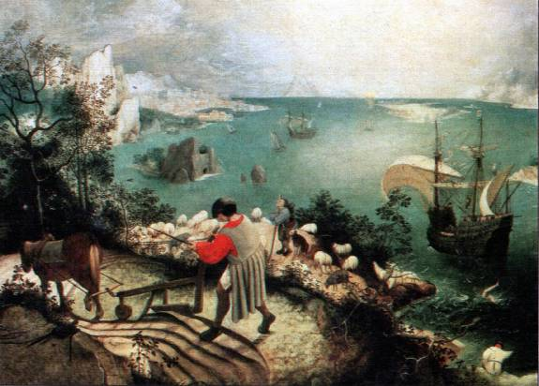
Landscape with the Fall of Icarus, Peter Breughel the Elder, 1558
Musee des Beaux-arts, Brussels
Licensed under Creative Commons

The Element of Mass

Mass, or form, refers to a shape or three-dimensional volume that has or gives the illusion of having weight, density or bulk. Notice the distinction between two and three- dimensional objects: a shape is by definition flat, but takes on the illusion of mass through shading with the elements of value or color. In three dimensions a mass is an actual object that takes up space. Eugene Delaplanche’s sculpture ‘Eve After the Fall’ from 1869 (below) epitomizes the characteristics of three-dimensional mass. Carved from stone with exaggerated physicality to appear bigger than life, the work stands heavily against the space around it. Delaplanche balances the massive sculpture by his treatment of the subject matter. Eve sits, her body turned on two diagonal planes, one rising, the other descending, her right hip being the meeting point of the two. She rests her head in her hand as she agonizes over the consequences of what she’s just done, the forbidden apple at her feet as the serpent slinks away to her left.

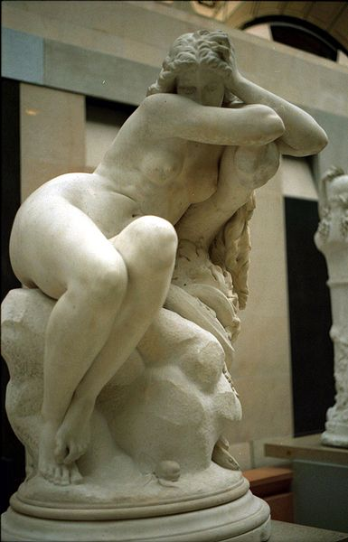
Eugene Delaplanche, Eve after the Fall, 1869. Marble
Musee d’Orsay, Paris
Photo by Rama and licensed under Creative Commons

Although actual mass and form are physical attributes to any three-dimensional work of art, they are manifested differently depending on the culture they are produced in. For example, traditional western European culture is known for its realistic styles, represented by Delaplanche’s ‘Eve after the Fall’. In contrast, look at the figurative sculpture from the Cameroon culture in Africa below to see how stylistic changes make a difference in the form. The sculpture is carved from wood, generally more available to the artist in sub-Saharan Africa than is marble. Moreover, the Cameroon figure stands upright and frontal to the viewer, and is carved without the amount of descriptive detail seen in Delaplanche’s work, yet the unknown African artist still gives the figure an astonishing amount of dramatic character that energizes the space around it.

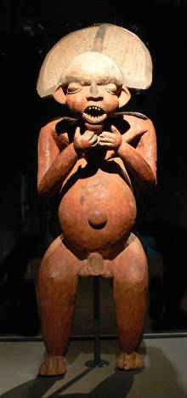
Male figure, Cameroon. c. 19th century. Artist unknown
Collection: Ethnological Museum, Berlin-Dahlem
Photo by Andreas Praefcke and licensed under Creative Commons

